**THEORY I**

[**Back to HCI Lab Home Page**](http://iitg.vlab.co.in/?sub=72&brch=170)

**Color properties**

**Hue**

Hue defines pure colors in terms of red, green or blue. Hue also defines mixtures of two pure colors like red-yellow or yellow-green.

|  |  |
| --- | --- |
| http://iitg.vlab.co.in/userfiles/7/image/hue.png | http://iitg.vlab.co.in/userfiles/7/image/uelabs/color%20theory/image1.png |

**Tint**

A tint is a mixing result of an original color to which has been added white. If you tinted a color, you've been adding white to the original color.

http://iitg.vlab.co.in/userfiles/7/image/tint.png

**Shade**

A shade is a mixing result of an original color to which has been added black. A shade is darker than the original color.

http://iitg.vlab.co.in/userfiles/7/image/shade%281%29.png

**Tone**

Tone is  result of mixing a pure color with any neutral/grayscale color including the two extremes white and black. By this definition all tints and shades are also considered to be tones.

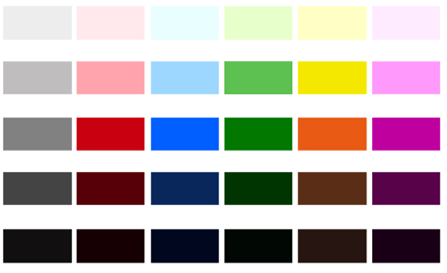

**Lightness  or  Value = Tone in percentage**

Lightness is usually one property of three when used to determine a certain color and measured as percentage value. Lightness defines a range from dark (0%) to fully illuminated (100%).Any original hue has the average lightness level of 50%. Lightness is the range from fully shaded to fully tinted. Value or tone is a measure of how light or dark a color is, without any consideration for its hue.

.

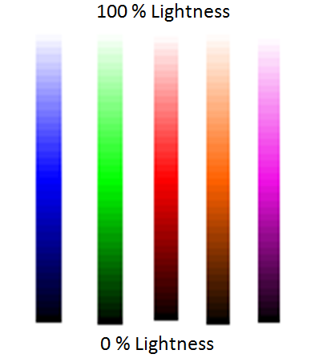

**Saturation or Chroma**

Saturation is usually one property of three when used to determine a certain color and measured as percentage value. Saturation defines a range from pure color (100%) to gray (0%) at a constant lightness level. A pure color is fully saturated. Saturation is the purity of a color. The chroma or saturation of a color is a measure of how intense it is. High saturation colors look rich and full. Low saturation colors look dull and grayish..

|  |  |
| --- | --- |
| http://iitg.vlab.co.in/userfiles/7/image/saturate.png | http://iitg.vlab.co.in/userfiles/7/image/uelabs/color%20theory/image3.png |

**Intensity / Luminosity**

It can be used in conjunction with any color property. **Luma** (%) is the intensity of the achromatic signal contributing to our color perception.

**Brightness / Luminicance**

Brightness is an attribute of our perception which is mainly influenced by a color's lightness. For one color of specific hue the perception of brightness is also more intense, if we increase saturation.

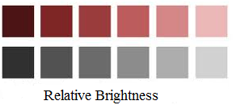

**Gray Scale**

A grayscale is a series of neutral colors, ranging from black to white, or the other way around. Each step's color value is usually shifted by constant amounts.



To proceed  further  click on the **THEORY II** tab on the top or to exit this experiment  click on **HOME**  on the top.

**THEORY II**

[**Back to HCI Lab Home Page**](http://iitg.vlab.co.in/?sub=72&brch=170)

**The color wheel**

A color wheel or color circle is an abstract illustrative organization of color hues around a circle that shows relationships between primary colors, secondary colors, complementary colors.



Begin a color wheel by positioning primary hues equidistant from one another, then create a bridge between primaries using secondary and tertiary colors.

**Primary Colors**

Colors at their basic essence; those colors that cannot be created by mixing others.  e.g. Red, yellow and blue.

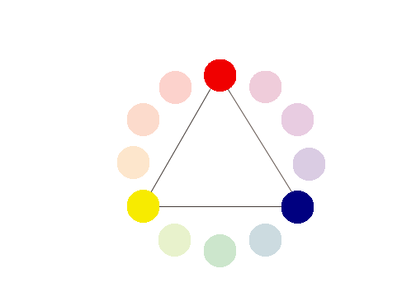

**Secondary Colors**

Those colors achieved by a mixture of two primaries.   
  
e.g. Green, orange and purple

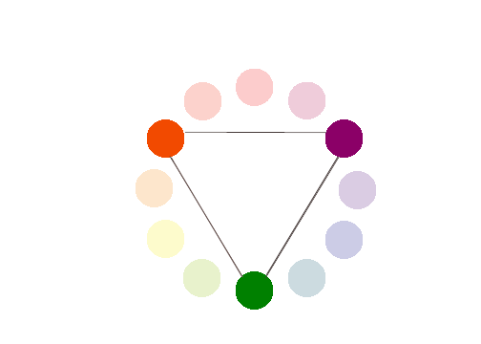

**Tertiary Colors**

Those colors achieved by a mixture of primary and secondary hues.

e.g. Yellow-orange, red-orange, red-purple, blue-purple, blue-green & yellow-green

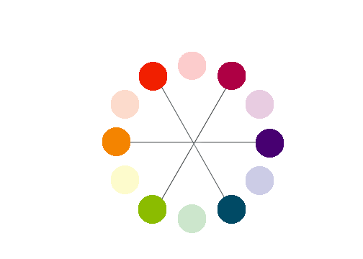

**Complementary Colors**

Those colors located opposite each other on a color wheel.

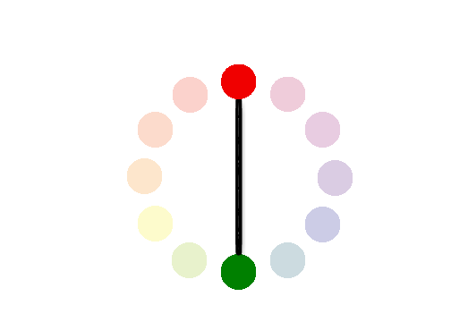

**Analogous Colors**

Those colors located close together on a color wheel.



***( Above content can be referenced at http://www.worqx.com/color/color_wheel.htm )***

**Color Context**

How color behaves in relation to other colors and shapes is a complex area of color theory. Compare the contrast effects of different color backgrounds for the same green square in figure below.

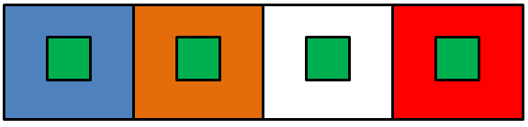

Green appears more brilliant in red background and duller against blue background. In contrast with white it exhibits brilliance.

To proceed  further  click on the **THEORY III** tab on the top or to exit this experiment  click on **HOME**  on the top.

**THEORY III**

#### [Back to HCI Lab Home Page](http://iitg.vlab.co.in/?sub=72&brch=170)

**Web Content Accessibility Guidelines (WCAG) 2.0**

Web Content Accessibility Guidelines (WCAG) 2.0 covers a wide range of recommendations for making Web content more accessible. These guidelines will also often make your web content more usable to users in general.

**Principles of Accessibility**

Anyone who wants to use the Web must have content that is:

* **Perceivable**-Information and user interface components must be presentable in ways they can be perceived.
* **Operable** - User interface components and navigation must be operable.
* **Understandable** - Information and the operation of user interface must be understandable.
* **Robust** - Content must be robust that it can be interpreted reliably by a wide variety of user agents and  assistive technologies.

**Guidelines for making content perceivable**

* Provide text alternatives for non-text content – like braille, speech etc
* Provide alternatives for time-based media.
* Create content that can be presented in different ways.
* Make it easier to see and hear content separating foreground from background.

**Color Text Legibility**

**W3C Guidelines for color readability**

The brightness difference between foreground text-color and background-color should follow the formulae suggested in W3C Guidelines for good text-color visibility.

**Color visibility algorithm (suggested by W3C standard)**

Two colors provide good color visibility if the brightness difference and the color difference between the two colors are greater than a set range.

|  |
| --- |
| **Color brightness** = ((Red value X 299) + (Green value X 587) + (Blue value X 114)) / 1000     For good color visibility brightness difference should be  **> 125** |

|  |
| --- |
| **Color difference** =     (maximum (Red value 1, Red value 2) - minimum (Red value 1, Red value 2)) +     (maximum (Green value 1, Green value 2) - minimum (Green value 1, Green value 2)) +     (maximum (Blue value 1, Blue value 2) - minimum (Blue value 1, Blue value 2))    For good color visibility color difference should be > **500** |

**Note :**

These formulae are only suggestions and are not reliable to full extent. In actual practice you are expected to test the color combinations again and again for readability.

  To proceed  further  click on the **OBJECTIVE** tab on the top or to exit this experiment  click on **HOME**  on the top.

#### OBJECTIVE

#### [Back to HCI Lab Home Page](http://iitg.vlab.co.in/?sub=72&brch=170)

Some websites and services allow you to customize your profile by uploading pictures, changing the background color or other aspects of the design. Opening up the ability to customize your site’s color scheme can be a recipe for disaster unless you are flexible and understand how to find maximum color contrasts.

**At the end of this experiment**

1. You will understand the fundamental properties of color, color wheel and color context.

2. You will be able to apply color theory in creating attractive web content.

3. You will understand essential features required for color text legibility on web pages.

4. You will be able to apply W3C guidelines for color text readability on web pages.

 To proceed  further  click on the **PROCEDURE** tab on the top or to exit this experiment  click on **HOME**  on the top.

**PROCEDURE**

[**Back to HCI Lab Home Page**](http://iitg.vlab.co.in/?sub=72&brch=170)

The simulation based experiment allows you to apply various colors to text as well as its background and create different color contrasts.

To activate this simulation program go to simulator tab and click on the relevant button.

**Steps for experiment**

 The screen consists of two sections

(a) website window  - black outline

(b) color- setting window  -- blue outline

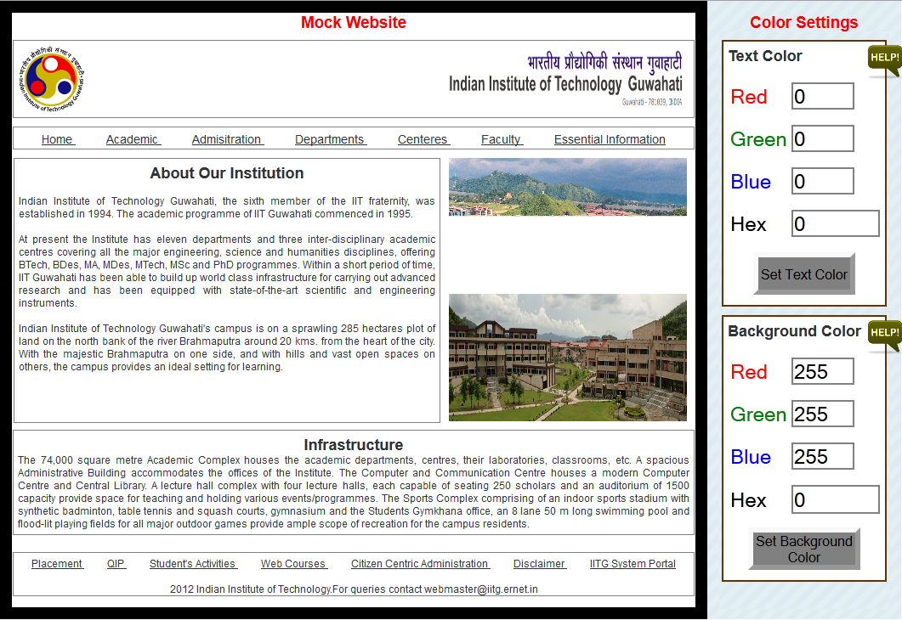

**Website  Window**

1. You will  see  a   mock  web-site  of  IITG, Guwahati  in  this  window  with  broad black  outline.
2. Various  sections of  this  homepage  have  been  identified  with  thin black  borders.
3. You can select any of these sections by clicking within its boundary.
4. When you select  a   section the color of its border will change to red.
5. You can now use color setting window to set colors of this selected  section.
6. Unless you select a section from  the homepage the color setting will not be applied.

**Color-setting  window** (Text  color  setting)

1. You can give the RGB color values required through the input boxes provided. The  converted hex color code  will  automatically  be displayed.
2. To apply this color to text press  the  **<set color>** button.
3. Visa-versa  if  you  know  the  hex color code  of a color, you  can  directly  enter  it  in the input box  provided.  The corresponding RGB color values  will be computed  and dislayed after  you  press  **<set color>** button.
4. Using color selection slider -  In case  of  hex color code setting,  a  color  selection  slider  can  be  used which  will  give  you an immediate visual  feedback  of  the  color  selected. Press **<OK>**  button  to  select  the  color  identified  using  the  slider.
5. Remember  that  the  **<set  color>**  button  will  apply  the  text  color settings  only  to  the selected section  of  the  website.

**Color-setting  window** (Bakground color setting)

1. Same as above you can give the RGB color values required in the input boxes provided.
2. To apply this color setting to background press same **<set color>** button.  The converted hex code of  the  color will automatically be  computed and displayed.
3. Visa-versa  if  you  know  the  hex color code  of a color, you  can  directly  enter  it  in the input box  provided.  The corresponding RGB color values  will be computed  and dislayed after  you  press  **<set color>** button.
4. Using color selection slider - A similar color selection slider is available for selecting background color  with  hex  values. Use  this  slider  if  required  and  press **<OK>** button in  the end.
5. Remember  that  the  **<set  color>**  button  will  apply  the  background  color settings  only  to  the selected section  of  the  website.

You can experiment by selecting different sections of the home-page in the mock website window and apply various text and background colors.

Apply the color **brightness difference** and **color difference** formulae to see if they really work in practice improving legibility of the color text.

To proceed  further  click on the **SIMULATOR** tab on the top or to exit this experiment  click on **HOME**  on the top.

**SIMULATOR**

#### [Back to HCI Lab Home Page](http://iitg.vlab.co.in/?sub=72&brch=170)

 To activate the simulation   :   [http://iitg.vlab.co.in/userfiles/7/image/uelabs/dwnld.png](http://125.20.82.167/uelabs/exp10/index.html)

 To proceed  further  click on the **QUIZ** tab on the top or to exit this experiment  click on **HOME** on the top.

**QUIZ**

[**Back to HCI Lab Home Page**](http://iitg.vlab.co.in/?sub=72&brch=170)

1. What do you mean by tone and saturation of  a color?
2. What  is  the difference between tint and shade of  a color?
3. What are primary, secondary and tertiary  colors?
4. What  is  the  practical significance  of  the concept  "color context" ? Give examples.
5. Find the range of wavelengths that are visible to human eye.
6. What does CMYK and RGB stand for ?
7. What are web-safe  colors?
8. What  is  color  visibility  algorithm? What  is the W3C guideline for color  readability?
9. Explain  principles  of  web acessibility  in  brief.

To proceed  further  click on the **ASSIGNMENT** tab on the top or to exit this experiment  click on **HOME**  on the top.

**ASSIGNMENTS**

#### [Back to HCI Lab Home Page](http://iitg.vlab.co.in/?sub=72&brch=170)

In the figure below there are five colored backgrounds B1- B5 and five colored texts T1- T5.

Using W3C guidelines for color readability (using color brightness and color difference) find the

**text-background pairs** from below for best color text legibility.

Use hex codes of colors in computations.

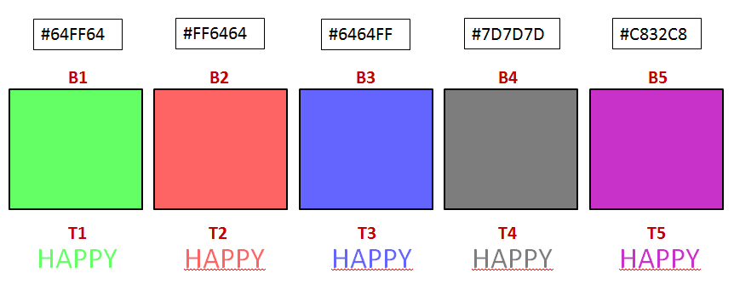

In  the figure  below  which  of  the  webpage  color  combinations  is  the best.

( Use  online color-picker  tool  to  get  color  codes -  http://www.iconico.com/colorpic/   )

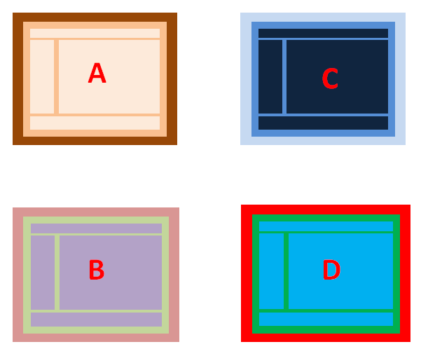

 To proceed  further  click on the **REFERENCE** tab on the top or to exit this experiment  click on **HOME** on the top.

**REFERENCES**

#### [Back to HCI Lab Home Page](http://iitg.vlab.co.in/?sub=72&brch=170)

**Books**

|  |  |  |
| --- | --- | --- |
| http://iitg.vlab.co.in/userfiles/7/image/book1.png | http://iitg.vlab.co.in/userfiles/7/image/book2.png | http://iitg.vlab.co.in/userfiles/7/image/book3.png |

**URLs** ( as on 23/4/2012)

http://www.workwithcolor.com/color-properties-definitions-0101.htm

http://www.colormatters.com/color-and-design/basic-color-theory

http://www.w3.org/TR/UNDERSTANDING-WCAG20/intro.html#introduction-fourprincs-head

http://www.hgrebdes.com/colour/spectrum/colourvisibility.html

http://www.techbomb.com/websafe/

http://samples.msdn.microsoft.com/workshop/samples/author/dhtml/colors/ColorTable.htm

http://donnayoung.org/art/color-theory.htm

## 

 To give feedback  for this experiment click on the **FEEDBACK** tab on the top or to exit this experiment click on **HOME**  on the top.